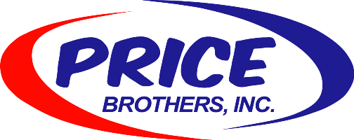
Price Brothers has been in business for 38 years and provides:
- 40+ Hour Work Week
- Optional Overtime that pays 1 ½
- Bonus Incentive Programs including “Eagles & Bird Dogs”
- 401k Matching %
- Vacation
- Dental Insurance
- Vision Insurance
- Life Insurance
- Health Insurance
- Paid Holidays (6 minimum)
- Paid Vacation (Up to 3 weeks)
- Family Oriented Flexibility (time off when needed)
- Health Discount for Wellness Program Participation
- Prescription Drug Coverage
- Flexible Spending Account
- Health Savings Account
- Paid Travel Time
- PBI Apparel
- Family Events
- Christmas Party
- Verizon Phone Discount

Over the past 8 years, 5 plumbing companies with over 100 employees each failed and are no longer in business.

